# Chapter 4

## User registration

The user has to register with the system in order to use it. To register they have to fill a form shown in figure 1.1. after filling the form, the information is sent to a server for processing after a successful registration their information is stored in database.

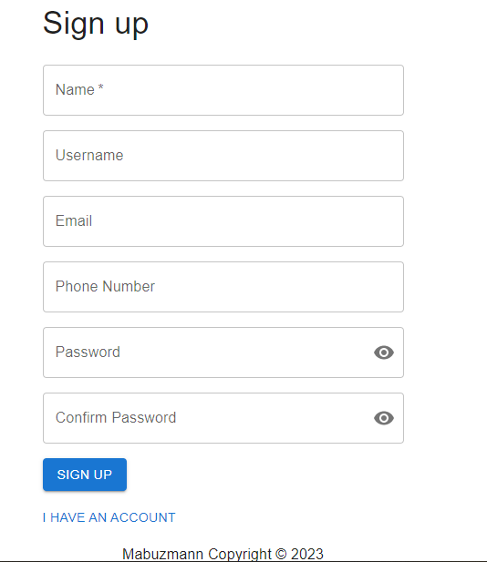

Figure .

User information stored in the database is shown in figure 1.2. The password is encrypted before it is stored in the database.

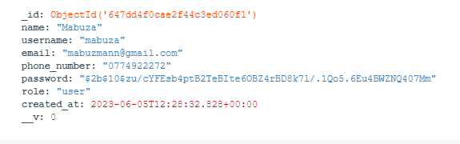

Figure .

## Login system

For a user to access the system they have to login using a combination of their username and password. The users fill in the form showed in figure 1.3. When either of the provided information is incorrect the user will be presented with an appropriate error message.

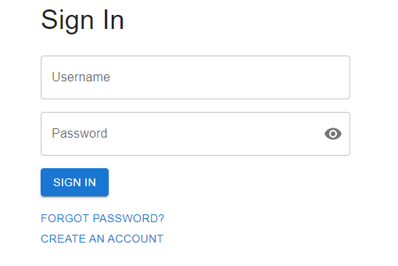

Figure .

## Dashboard

After a successful login the user is taken to a dashboard page where a list of vehicles which they are authorized to drive and their location on a map. If the user has no vehicles which they are authorized to drive they will be presented with a message shown in figure 1.4.



Figure .

When a user has vehicles which they are authorized to drive, the dashboard page will look like figure 1.5. One the left a list of authorized vehicles is shown. On the right the location of vehicles is shown on the map.

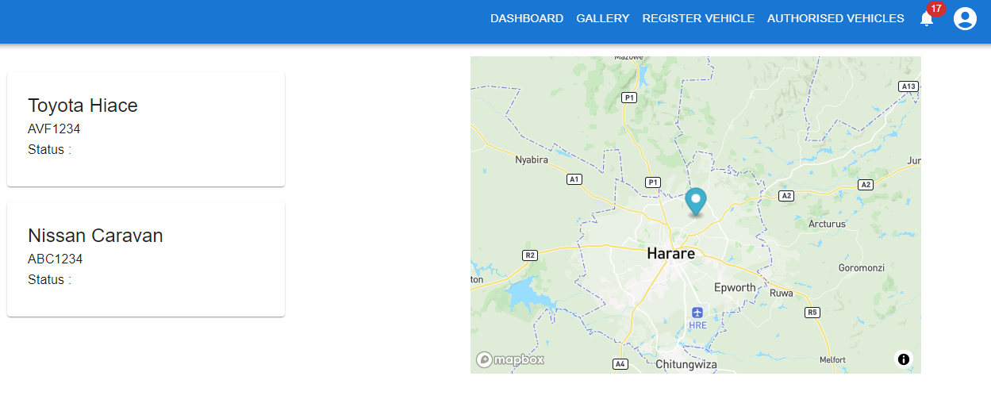

Figure .

## Vehicle Registration

If a user does not have vehicle which they are authorized to drive they can register their own vehicle on the vehicle registration page which is shown in figure 1.6.

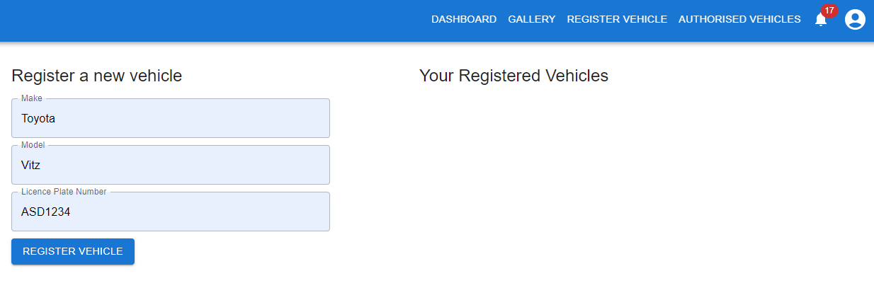

Figure .

After registering the vehicle, the vehicle will appear under “Your Registered Vehicle” section of the page as shown in figure 1.7.

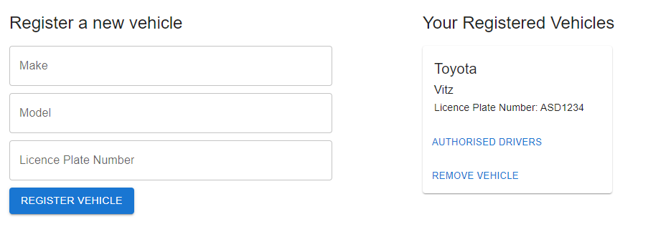

Figure .

The vehicle is added to the database with the owner added as the first driver on the drivers’ list as shown in figure 1.8.

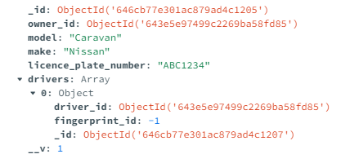

Figure .

Since the fingerprint scanner uses id range from 1 to 127 the driver is initially given an id of -1 which is invalid.

On the registered vehicle card there are two buttons, one the deregister the vehicle (Remove Vehicle) and Authorized Drivers button which takes the user to a page that shows a list of drivers who are authorized to drive that vehicle. The page is shown in figure 1.8. There is a button on that page that allows the owner of the vehicle to authorize other users to drive their vehicle. Once added the vehicle will now appear on their dashboard and they can now track the vehicle’s location. On the driver’s card there is a delete icon to remove a driver from authorized driver of that vehicle.

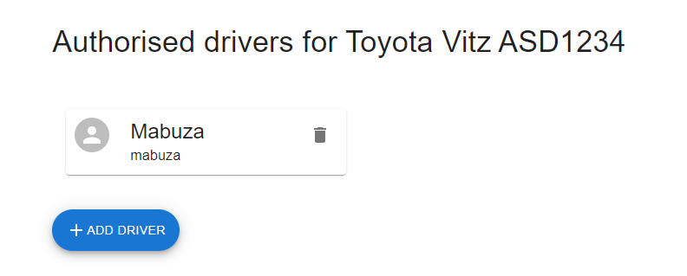

Figure .

To add a driver to authorized drivers they click the add driver button and an input field pops up where they can enter the user’s username then they are added to the list.

## Authorised Vehicles page

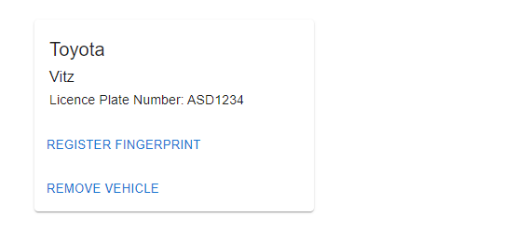

Figure .

On the Authorised Vehicles page, that user’s vehicles that they are authorized to drive are shown. Those cards have two buttons initially, one to register their fingerprint on the vehicle and one to de register themselves from driving that vehicle. When the user wishes to register their fingerprint in order to use the vehicle, they click the “Register Fingerprint” button. Then they have to follow some instructions on a screen in the vehicle. After a successful fingerprint the “Register Fingerprint” button disappears and, in the vehicles’ database collection the driver’s fingerprint id field is updated with the new fingerprint id from the vehicle hardware.

## Vehicle Hardware

The vehicle has a seat sensor on the driver’s seat which detects the presence of the driver on the seat, the vehicle will not start if there is no driver on the driver’s seat. When the driver ha sat on the seat, they can press the start button and a message on the LCD will instruct the driver to scan their fingerprint on the fingerprint scanner as shown in figure 1.11.

After the fingerprint has been authenticated successfully the hardware will start the car engine and print the message on an LCD. There is an LED that indicates that the engine has started and another that indicates that the drive gear can be engaged meaning the vehicle can be driven. When a driver moves away from the seat the system will lock the gears but keep the engine running, this prevents the vehicle from being driven by another individual besides the driver. To drive the vehicle, they have to rescan their fingerprint once they are on the seat.

During fingerprint registration the user id of the driver is sent to the vehicle and after they enroll their fingerprint successfully their fingerprint id and user id are stored in a local database in the vehicle. The database is shown in figure 1.12.

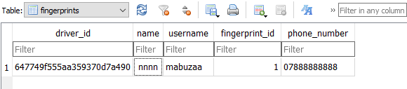

Figure .

When a user scans an unidentified fingerprint for more than 2 times the system sounds an alarm to alert the user, they have used an unidentified fingerprint a WhatsApp message is then sent to the owner of the vehicle. The message will notify the owner about the incident together with the location of the vehicle. A screenshot of the message is shown in figure 1.13

When the driver is in state of emergency, they have a panic button at their disposal. When the panic button is pressed a WhatsApp message is sent to every driver authorized to use that vehicle that the driver is in a state of emergency together with their location. A screenshot of the message is shown in figure 1.14.